**Healthcare Data Interoperability Solution**

**Solution Overview:-** This solution is developed for the various healthcare organizations like Hospitals, Insurance companies, Pharmacies, Lab diagnostic centers, Scan centers etc., to exchange the health information about patients and their medical records electronically between them. A standard data format was developed and nurtured by HL7 International known as FHIR. Fast Healthcare Interoperability Resources (FHIR) is a Health Level Seven International® (HL7®) standard for exchanging healthcare information electronically.

We can convert existing health information into FHIR format by utilizing Azure services such as Azure Health Data Services, Azure FHIR Service, Azure Integration Services (Azure Function, Azure Logic App, Event Grid Topic,) and storing them into Azure data repository (Azure Cosmos DB, Azure SQL, Azure blob Storage) which will be useful for further analysis when we are exchanging the health information between medical devices.

**Architecture diagram of Solution:**

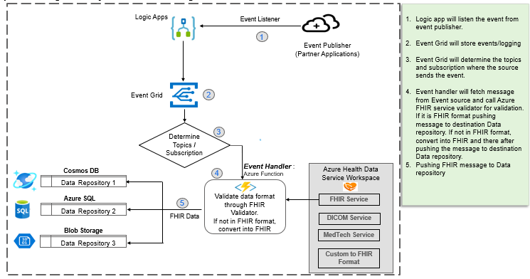

**Implementation steps:**

**Event Publishers:**

There are multiple event publishers like hospitals, who will provide information on patient resources along with the name of the hospital where the data is stored in the API.

Particularly, Events Publishers like below Api's are created.





**Event Listener:**

Introduce Azure Logic App . When an event is published, the event listener receives the event from the event publishers and provides the event data and information to the event grid topic.

Here Azure Logic App is the listener as shown below.

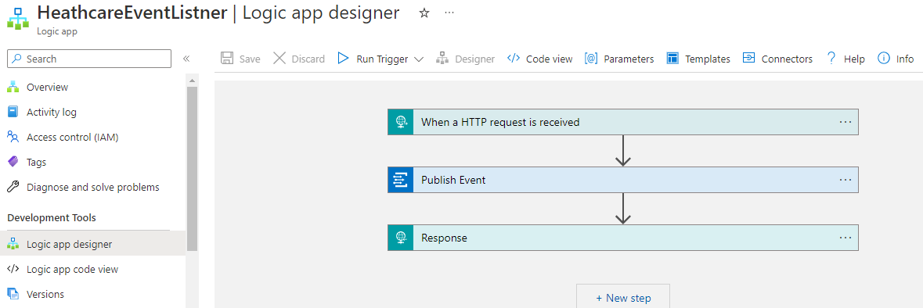

Event Listeners flow:

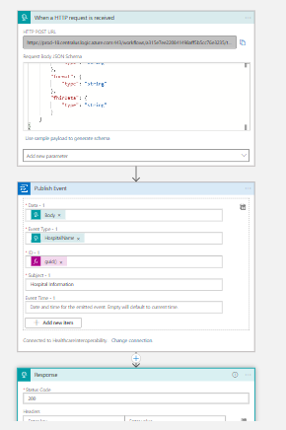

**Event Grid Topic:**

Leverage Event Grid Topic where data and relevant details will be received by Event Grid Topic from the event listeners, and the data will be filtered based on the event type indicated in the event data to determine which subscription it needs to pass.

Event grid topic is created with multiple subscriptions as shown below.

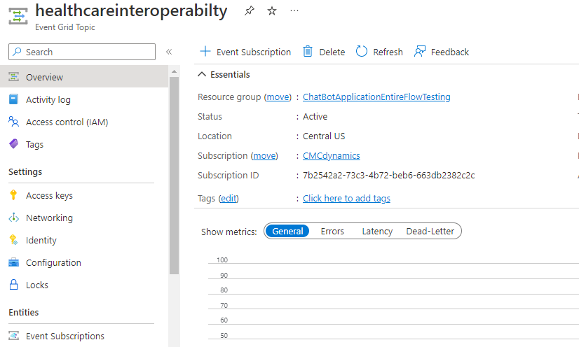



**Event Subscription:**

Created Event Subscriptions which have the appropriate event handlers and subscribe to the event grid topic.

Here, one Event grid Topic has many event subscriptions subscribed to it as shown below.

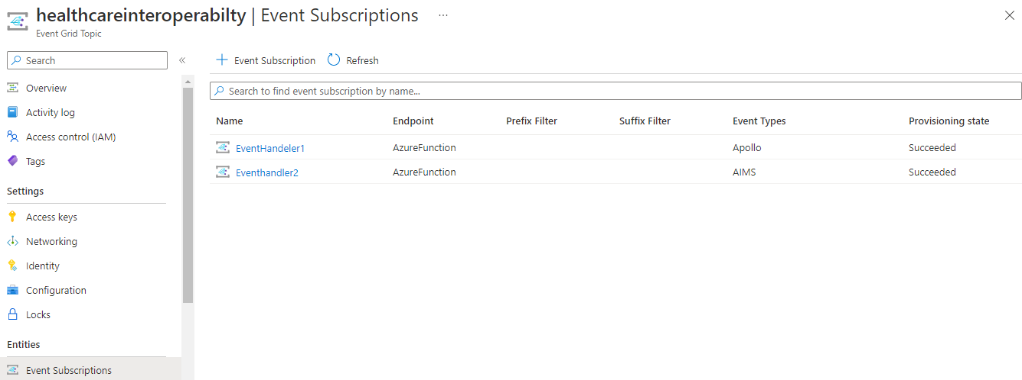

**Event Handlers:**

Created Event handlers by leveraging Azure function which are configured as subscriptions and receive the filtered event data. Every event handler will perform the following actions.

We have several event handlers configured here, including Azure functions and webhooks as shown below.





Each event handler will carry out the following actions.

1. Obtain the relevant hospital information from the API and validates the data against the FHIR service.

2. If the validation is successful, the data is saved in the appropriate database.

3. If validation fails, data is converted to the FHIR format using an FHIR service.

Please see the detailed steps below:

We must first establish the health data workspace in order to use the Azure FHIR service. The Azure FHIR service must be created on that workspace.

Azure Health data workspace:

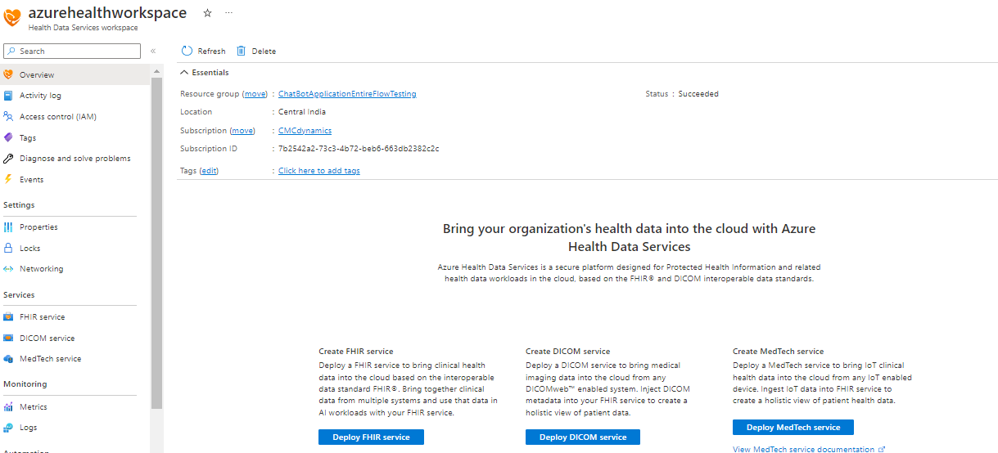



**Azure FHIR Service:**

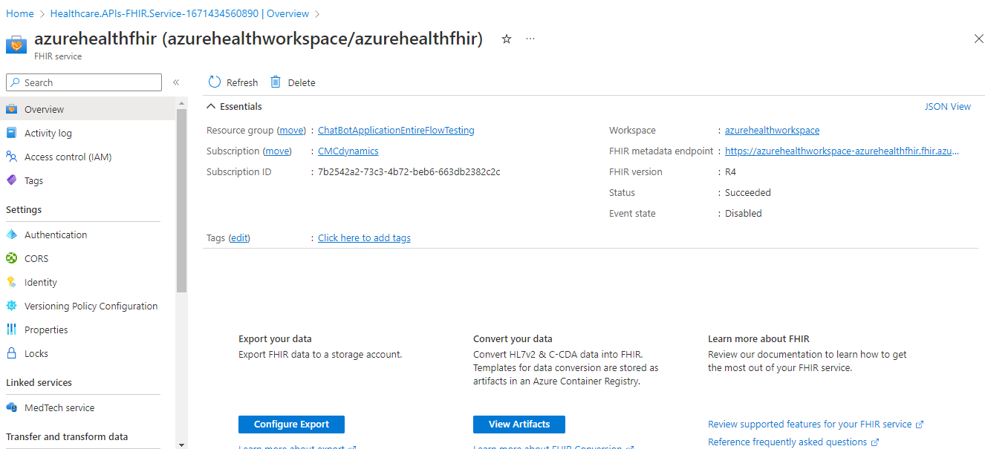



1. It retrieves the data from the data source API and then validate it against the FHIR service's Validate API as shown in below screenshot.

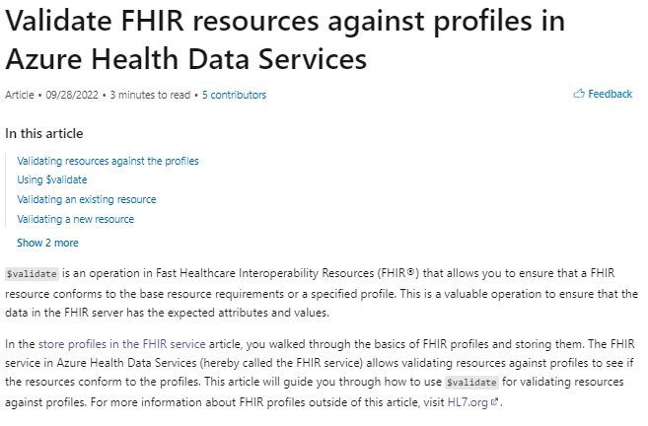

2. Upon successful validation, the data is saved to the Azure Cosmos DB/ Azure SQL/ Blob Storage.

3. If the validation process is unsuccessful, the FHIR service's Convert API is called, which returns the transformed data in FHIR format, which is subsequently saved into the Azure Cosmos DB/ Azure SQL/ Blob storage

Here is the convert method in FHIR 